System Requirements Statement (SRS) –

Agronomy Shopping System.

Doc. Ref. : SRS_v0.4.doc

Version : 0.1

Status : Drafted

Created by : Group no 7

Date : 21-Jan-2022 to 02-Mar 2022

1. Introduction 3

2. Functional Requirements 4

2.1 Seller Module 5

2.2 Customer Module 13

2.3 admin Module 21

2.4 Diagram........................................................................................................................25

THIS DOCUMENT CONTAINS 27 NUMBERED PAGES

# Introduction

This document explains the system requirements and scope for developing Agronomy Shopping System.

Agronomy Shopping System

Could divide the three main parts Seller part, Customer part and the Admin part.

# Functional Requirements

The Account part of Agronomy Shopping System has three modules which are divided 27 processes described as below.

|  |  |  |
| --- | --- | --- |
| **No** | **BRS requirement ID** | **Description** |
| **2.1** | **SELLER MODULE** | |
| **2.1.1** | **F1** | **Login Process.** |
| **2.1.3** | **F3** | **Update Account Process.** |
| **2.1.2** | **F2** | **Forgot Password Process.** |
| **2.1.4** | **F4** | **Manage Product Catalogue.** |
| **2.1.5** | **F5** | **Confirm Customers Order Request.** |
| **2.1.6** | **F6** | **Give Discount To Customer.** |
| **2.1.7** | **F7** | **Give Refund.** |
| **2.1.8** | **F8** | **Assist After Sales.** |
| **2.2** | **CUSTOMER MODULE** | |
| **2.2.1** | **F9** | **Account Registration Process.** |
| **2.2.2** | **F10** | **Login Process.** |
| **2.2.3** | **F11** | **Forgot Password Process.** |
| **2.2.4** | **F12** | **Update Account Process.** |
| **2.2.5** | **F13** | **Search Product.** |
| **2.2.6** | **F14** | **View Product Details.** |
| **2.2.7** | **F15** | **Manage Cart.** |
| **2.2.8** | **F16** | **Confirm order.** |
| **2.2.9** | **F17** | **Check Order Status.** |
| **2.2.10** | **F18** | **Request For Assistance.** |
| **2.2.11** | **F19** | **Generate Refund Request.** |
| **2.2.12** | **F20** | **Give Feedback.** |
| **2.3 ADMIN MODULE** | | |
| **2.3.1** | **F21** | **Login Process.** |
| **2.3.2** | **F22** | **Forgot Password Process.** |
| **2.3.3** | **F23** | **Update Account Process.** |
| **2.3.4** | **F24** | **Add Seller.** |
| **2.3.5** | **F25** | **Manage Product Catalogue.** |
| **2.3.6** | **F26** | **Generate Sales Report.** |
| **2.3.7** | **F27** | **Enable/Disable Accounts.** |

## SELLER MODULE

* Seller is the user of system who wants to sale the product.
* Seller will get UserId and password after thorough verification by admin.

### Login Process

* Agronomy Shopping System always compels user authentication before using itself except when a new account is successfully created.
* The user authentication demands UserID and Password. The UserID and the Password should be checked in three ways.
  + First, The UserID and the Password should be existed and correct.
* If The UserID and the Password are not equal to what the user has registered, the user authentication cannot be provided.
  + Second, the User Type linked to the UserID should be "Customer".
* When the User Type is "Seller", then user can be placed on Customer Home”.
  + Finally, UserID should be available.
* The Administrator can decide whether the UserID is available or suspended – Refer to the SRS of the Admin part.
* If Customer is rejected, user authentication is not provided for system user.
* The Customer account should alive for so long as the duration decided by Admin.
* Only when the three checks are successfully completed, Seller can be placed on respected page.
* The “Seller Home” provides the some items described as below.
* A trigger to logout
* A trigger to update Account
* A trigger to Change Password
* A trigger to Search Product
* A trigger to Update Product Information
* A trigger to Publish Product for sale
* A trigger to Delete Product.
* A trigger to respond to the customer’s request.

### Update Account Process

* Agronomy Shopping System should provide the function which makes the account updated for Seller.
* The information Seller could update is described below.

1. Login information
2. User information
3. Security Question Information

* The Login information

The updatable items as described below.

1. First Name
2. Last Name
3. E-mail address
   * All items are compulsory demanded, but updating is optional.

* The User information

The updatable items as described below.

1. User Name
2. User Phone No
3. E-mail address
4. Permanent address
   * All items are compulsory demanded, but updating is optional.

* The Security Question information

The updatable items as described below.

1. Selected Question
2. Answer
   * All items are compulsory demanded, but updating is optional.

### Change Password Process

* When Seller wants to change their Password, the measure should be provided by Agronomy Shopping System.
* Therefore Agronomy Shopping System should provide the function which is available after getting the Seller authentication.
* The function demands the current password and the new password.
  + Of course, the new password should consist of more than or equal 8 and less than or equal 16 characteristics including at least a numeric figure, a capital alphabet, a small alphabet, and a special character.
  + The current password and the new password are masked by using dummy characters.
  + The new password is demanded to enter twice to avoid a typing error.
* Only when the current password is correct, Seller could change their Password.
* When the current password is changed into new password, Agronomy Shopping System compels user authentication again.

### Forgot Password Process

* When system user lost their Password, the recovery method should be provided by Agronomy Shopping system.

The recovery method is described as below.

* + First, system user enters their UserID for Agronomy Shopping System.
  + Next, for Agronomy Shopping System demands the Answer which has been registered since when the Account was created.
  + Only when the Answer is correct, Seller get the new password by E-mail which also has been registered since when the Account was created.
  + The new password is automatically generated by for Agronomy Shopping System.
* Of course, the new password should consist of more than or equal 8 and less than or equal 16 characteristics including at least a numeric figure, a capital alphabet, a small alphabet, and a special character.
* As a consequence, The Seller could get the Seller authentication using the new password.
  + Then, the Seller had better change the new password manually.
* If the Answer is not correct, otherwise, the correct Answer is demanded for user again.
  + In that case, Of course, Seller couldn’t get the new password.

### Manage Product Catalogue.

### Photo.

* Seller will have provision for uploading images.
* Minimum one photo will be required about product.
* Image size must be less than 1mb.
* Image should be in .jpg , .png,.jpeg format.

### Product Description

* Seller Will be able to describe his products.
* Seller will be provided a text area for writing description.
* Maximum 200 words will be allowed for description.

### Product quantity.

* Product quantity added should always in positive number or zero for large Machineries.
* Product quantity should always be whole number
* Seller can increase the product quantity by adding new products of same category.

### Price.

* Price which are entered by seller should not be null
* Price is always nonzero amount.
* Price of the product is always in positive number .

### Product Unit

* Seller Will be able to describe his products unit.
* Seller will be able to select unit from kg/litre/unit for product.

### Update product into Catalogue

* Search conditions are described as below.

1. Product category
2. Product Name

### Photo.

* Seller will have provision for uploading images.
* Minimum one photo will be required about product.
* Image size must be less than 1mb.
* Image should be in .jpg , .png,.jpeg format.

### Product Description

* Seller Will be able to describe his products.
* Seller will be provided a text area for writing description.
* Maximum 200 words will be allowed for description.

### Product quantity.

* Product quantity added should always in positive number or zero for large Machineries.
* Product quantity should always be whole number
* Seller can increase the product quantity by adding new products of same category.

### Price.

* Price which are entered by seller should not be null
* Price is always nonzero amount.
* Price of the product is always in positive number .

### 6. Product Unit

* Seller Will be able to describe his products unit.
* Seller will be able to select unit from kg/litre/unit for product.

### Delete product from catalogue

* The seller account will have the authority to delete the products that he has added in the catalogue.
* The seller cannot interfere in products added by other manufacturers or seller .He can only delete his own added products from the catalogue.

### Confirm Customer Order Request.

* The seller will have option to approve the customer’s orders in case they are doing malpractices like, false orders or if the delivery location not available to seller or the contact info of the customers feels suspicious.
* The seller will have option to grant or revoke order request by looking for the customer details who ordered it. Details will be available to seller if he has received order request.
* Order is set is from customer side (status).

### Give Discount to Customer

* The Seller can give Discounts to customers based on the Quantity of product ordered .There will be a Discount per cent declared for products and if bulk order is given to the seller there may be a chance to receive a discount on the orders.

### Give Refund.

* Admin will validate the customers dissatisfaction and asked seller to send the refund.

### Assist After Sales.

* On customer request seller to provide information regarding installation and setup of equipment.
* On customer he also provides with guide on how to use various products the seller provides on the store.
* A detailed instruction manual can be provided as a **document** to download on customer end.
* If required can provide link to **video** on step by step instruction
* Seller to provide **contact** in case needed for servicing and or maintenance required also for other help regarding the products bought by the customer.

## CUSTOMER MODULE

### Account Registration Process.

* Agronomy Shopping System compels to create the account before using it. So, Agronomy Shopping System should provide the function which makes Customer creates new account after getting approval from Admin.
* When Customer creates new account, the function demands for information described as below.

1. Login information
2. Contact Details

* The Login information

The Login information consists of some items described as below.

1. UserID (Customer id)
2. Password
3. First Name
4. Last Name
5. E-mail address
6. User Type
   * All items are compulsory demanded.
   * UserID

* The UserID should be unique. If the UserID correspond with not case-sensitive to other which is previously registered, the UserID should not be registered as an account.
  + Password
* The Password has constrains which makes the Password consists of more than or equal 8 and less than or equal 16 characteristics including characters described as below.

1. Numeric figure (at least one)
2. Capital alphabet (A-Z)(at least one)
3. Small alphabet (a-z)(at least one)
4. Special character (#, $, %, &, etc.) (at least one)

* The Password is masked by dummy characters. The re-entering Password is demanded.
* The Password must be encrypted in Agronomy Shopping System.
  + User Type

The User Type falls into three categories described as below.

1. Seller
2. Customer
3. Administrator

* The User Type defines also three types of user; "Seller user", "Customer user", and "Administrator user”.
* In an Account Creation Process, the user can select Customer.
* No one could select The Administrator, because Administrator is implemented to Agronomy Shopping System in advance.
* Contact Details
* The Contact Detail consists of some items described as below.
  + 1. Permanent Address
    2. Contact Phone No
  + All items are compulsory demanded.
  + Permanent Address
* Permanent Address should be filled.
* But only the state should be selected from options.
* The Security Question information

The Security Question information is needed when Customer lost their Password. This information consists of two items described as below.

1. Selected Question
2. Answer
   * All items are compulsory demanded.
   * Some questions which are difficult to answer for anyone else are prepared in advance.

E.g. which color do you like most?

* + A question should be selected from options by the Customer, and the Answer is registered by the Customer.

Login information should be entered on one screen, and then Customer information and Security Question information should be entered on another screen.

### Login Process

* Agronomy Shopping System always compels user authentication before using itself except when a new account is successfully created.
* The user authentication demands UserID and Password. The UserID and the Password should be checked in three ways.
  + First, The UserID and the Password should be existed and correct.
* If The UserID and the Password are not equal to what the user has registered, the user authentication cannot be provided.
  + Second, the User Type linked to the UserID should be "UserId".
* When the User Type is "Customer", then user can be placed on “Customer Home”.
  + Finally, UserID should be available.
* The Administrator can decide whether the UserID is available or suspended – Refer to the SRS of the Admin part.
* If Customer is rejected, user authentication is not provided for system user.
* The Customer account should alive for so long as the duration decided by Admin.
* Only when the three checks are successfully completed, Customer can be placed on respected page.
* The “Customer Home” provides the some items described as below.
* A trigger to logout
* A trigger to update Account
* A trigger to Change Password
* A trigger to Search Product
* A trigger to View Product Description
* A trigger to View Product Feedbacks
* A trigger to Browse Products
* A trigger to check order status
* A trigger to request assistance after sales.
* A trigger to Give Feedback.

### Forgot Password Process

* When system user lost their Password, the recovery method should be provided by Agronomy Shopping system.

The recovery method is described as below.

* + First, system user enters their UserID for Agronomy Shopping System.
  + Next, for Agronomy Shopping System demands the Answer which has been registered since when the Account was created.
  + Only when the Answer is correct, Seller get the new password by E-mail which also has been registered since when the Account was created.
  + The new password is automatically generated by for Agronomy Shopping System.
* Of course, the new password should consist of more than or equal 8 and less than or equal 16 characteristics including at least a numeric figure, a capital alphabet, a small alphabet, and a special character.
* As a consequence, The Customer could get the Customer authentication using the new password.
  + Then, the Seller had better change the new password manually.
* If the Answer is not correct, otherwise, the correct Answer is demanded for user again.
  + In that case, Of course, Seller couldn’t get the new password.

### Update Account Process

* Agronomy Shopping System should provide the function which makes the account updated for Seller.
* The information Customer could update is described below.

1. Login information
2. User information
3. Security Question Information

* The Login information

The updatable items as described below.

1. First Name
2. Last Name
3. E-mail address
   * All items are compulsory demanded, but updating is optional.

* The User information

The updatable items as described below.

1. User Name
2. User Phone No
3. E-mail address
4. Permanent address
   * All items are compulsory demanded, but updating is optional.

* The Security Question information

The updatable items as described below.

1. Selected Question
2. Answer
   * All items are compulsory demanded, but updating is optional.

### Change Password Process

* When Customer wants to change their Password, the measure should be provided by Agronomy Shopping System.
* Therefore Agronomy Shopping System should provide the function which is available after getting the Seller authentication.
* The function demands the current password and the new password.
  + Of course, the new password should consist of more than or equal 8 and less than or equal 16 characteristics including at least a numeric figure, a capital alphabet, a small alphabet, and a special character.
  + The current password and the new password are masked by using dummy characters.
  + The new password is demanded to enter twice to avoid a typing error.
* Only when the current password is correct, Customer could change their Password.
* When the current password is changed into new password, Agronomy Shopping System compels user authentication again.

### Search Product

* Search conditions are described as below.
  1. Product category
  2. Product Name.

### View Product Details

* Customer can see the product Details provided by Seller.
* As the result of searching Requirements, Customer could see the list of products which are available for sale.

1. Product category
2. Product Name.
3. Price.
4. Photos.
5. Description of product.
6. View Product Feedback.

### View Product Feedback

* Customer should select the product about which feedback to be displayed..
* Customer can view the product feedback which was given by other Customer.
* Customer can see the product Rating which was given by other Customer.

### Manage Cart.

### Add Product To Cart

* Customer after checking price ,feedback of the product he can add the product to the cart.

### Delete product from Cart

* If customer want to remove after adding the product into the cart he have the option to delete the product from his cart.

### Confirm Order.

* To buy the product followings are the condition

1. Product category.
2. Product Name.
3. Photo
4. Product Quantity.
5. Price.
6. Delivery Address.

### Check order status.

* Customer after buying product can check his order status like.

1. Order Confirmed
2. Dispatched.
3. Ready for delivery (with contact no).
4. Delivered.

### Customer Can Request For Assistance

* Customer will be provided contact details to communicate with the seller .

### Customer Can Request For Refund.

* After Customer Cancels the product a request for refund will be Generated.
* Bank details info will be taken and shared it with admin to seller.
* Request will be send to admin (manage refund).
* Show all the products in the order and then click on the hyperlink for generating the refund request by raising complaint in text area.

### Give Feedback.

* After the Products is Purchased by customer he will be able to give the feedback
* Customer will able to rate the product on a scale of 1 to 10
* 1 will be lowest rating
* 10 will be highest rating
* Average of all rating will be made available to customer.
* A text area will be provided for Customer to write review.

## ADMIN MODULE

* Administratorshould be responsible for following activities**.**

### Login Process

* Agronomy Shopping System always compels user authentication before using itself except when a new account is successfully created.
* The user authentication demands UserID and Password. The UserID and the Password should be checked in three ways.
  + First, The UserID and the Password should be existed and correct.
* If The UserID and the Password are not equal to what the user has registered, the user authentication cannot be provided.
  + Second, the User Type linked to the UserID should be "UserId".
* When the User Type is "Admin", then user can be placed on “Admin Home”.
  + Finally, UserID should be available.
* The Administrator can decide whether the UserID is available or suspended – Refer to the SRS of the Admin part.
* If Customer is rejected, user authentication is not provided for system user.
* Only when the three checks are successfully completed, Admin can be placed on respected page.
* The “Admin Home” provides the some items described as below.
* A trigger to logout
* A trigger to update Account
* A trigger to Change Password
* A trigger to approve or reject request
* A trigger to manage refund.
* A trigger to generate sales report.
* A trigger to enable/disable account.

### Forgot Password Process

* When system user lost their Password, the recovery method should be provided by Agronomy Shopping system.

The recovery method is described as below.

* + First, system user enters their UserID for Agronomy Shopping System.
  + Next, for Agronomy Shopping System demands the Answer which has been registered since when the Account was created.
  + Only when the Answer is correct, Seller get the new password by E-mail which also has been registered since when the Account was created.
  + The new password is automatically generated by for Agronomy Shopping System.
* Of course, the new password should consist of more than or equal 8 and less than or equal 16 characteristics including at least a numeric figure, a capital alphabet, a small alphabet, and a special character.
* As a consequence, The Admin could get the Admin r authentication using the new password.
  + Then, the Admin had better change the new password manually.
* If the Answer is not correct, otherwise, the correct Answer is demanded for user again.
  + In that case, Of course, Admin couldn’t get the new password.

### Update Account Process

* Agronomy Shopping System should provide the function which makes the account updated for Admin.
* The information Admin could update is described below.

1. Login information
2. User information
3. Security Question Information

* The Login information

The updatable items as described below.

1. First Name
2. Last Name
3. E-mail address
   * All items are compulsory demanded, but updating is optional.

* The User information

The updatable items as described below.

1. User Name.
2. User Phone No.
3. E-mail address.
4. Permanent address.
   * All items are compulsory demanded, but updating is optional.

* The Security Question information

The updatable items as described below.

1. Selected Question
2. Answer
   * All items are compulsory demanded, but updating is optional.

### Change Password Process

* When Admin wants to change their Password, the measure should be provided by Agronomy Shopping System.
* Therefore Agronomy Shopping System should provide the function which is available after getting the Seller authentication.
* The function demands the current password and the new password.
  + Of course, the new password should consist of more than or equal 8 and less than or equal 16 characteristics including at least a numeric figure, a capital alphabet, a small alphabet, and a special character.
  + The current password and the new password are masked by using dummy characters.
  + The new password is demanded to enter twice to avoid a typing error.
* Only when the current password is correct, Admin could change their Password.
* When the current password is changed into new password, Agronomy Shopping System compels user authentication again.

### Add Seller

* Admin has to enter the email id of seller and default password for creating the account. After first login details of the seller can be updated.

### Manage Product Catalogue.

### Create Product Catalogue

* Publish products requirements are described as below.
* Arrange in proper sequence

1. Product Category.
2. Product Name.
3. Photo.
4. Product Description.
5. Price.
6. Product quantity.
7. Unit

### 1.Product Category.

* Admin will specify the category of the product .
* The different categories which Admin can specify are.

1. Seeds.
2. Fertilizers.
3. Pesticides.
4. Herbicides.
5. Machineries.

### 2.Product Name.

* Admin will add Product Name.
* The name entered should be minimum 4 letters and maximum 20 letters.
* The name can contain only alphabets(A-Z) and Numerical(0-9).
* Each product must be listed with name.

### Photo.

* Admin will give provision for uploading images.
* Minimum one photo will be required about product.
* Image size must be less than 1mb.
* Image should be in .jpg , .png,.jpeg format.

### Product Description

* Admin will provide a text area for writing description.
* Seller Will be able to describe his products.
* Maximum 100 words will be allowed for description.

### Price.

* Admin will provide a text box for Price.
* Price which are entered by seller should not be null.
* Price is always nonzero amount.
* Price of the product is always in positive number .

### Product Quantity.

* Admin will Provide a textbox for quantity.
* Product quantity added should always in positive number or zero for large Machineries.
* Product quantity should always be whole number
* Seller can increase the product quantity by adding new products of same category.

### Product Unit

* Admin will Provide a textbox for Unit.
* Seller Will be able to describe his products unit.
* Seller will be able to select unit from kg/litre/unit for product.

### Update product into Catalogue

* Search conditions are described as below.

1. Product category
2. Product Name

* After publishing the product the Seller can only update following contents.

1. Product Category.
2. Product Name.
3. Photo.
4. Product Description.
5. Price.
6. Product quantity.

### 1.Product Category.

* Seller will have to specify the category of the product while listing the product.
* The different categories which Seller can specify are.

1. Seeds.
2. Fertilizers.
3. Pesticides.
4. Herbicides.
5. Machineries.

### 2.Product Name.

* While listing the product Seller has to enter the name.
* The name entered should be minimum 4 letters and maximum 20 letters.
* The name can contain only alphabets(A-Z) and Numerical(0-9).
* Each product must be listed with name.

### 3.Photo.

* Seller will have provision for uploading images.
* Minimum one photo will be required about product.
* Image size must be less than 1mb.
* Image should be in .jpg , .png,.jpeg format.

### 4.Product Description

* Seller Will be able to describe his products.
* Seller will be provided a text area for writing description.
* Maximum 200 words will be allowed for description.

### 5.Price.

* Price which are entered by seller should not be null
* Price is always nonzero amount.
* Price of the product is always in positive number .

### Delete product from catalogue

* The seller account will have the authority to delete the products that he has added in the catalogue.
* The seller cannot interfere in products added by other manufacturers or seller .He can only delete his own added products from the catalogue.

### Generate Report.

* Admin should able to see all the records from any users.
* Admin will be able to generate sales report.
* Admin will be able to generate report about sellers and customers.

### Enable/Disable Accounts.

* Admin should able to manage all the accounts with following activities.

1. Enable accounts.
2. Disable accounts.
3. **Enable Account.**

* If due to some reasons customer or sellers account is disabled admin will enable their accounts on request with proper verification.

1. **Disable Account.**

* Admin will have all control to disable the account of both customer and seller on being found defaulter or violating agronomy shopping system guidelines.

## DIAGRAM.

### Seller Module.

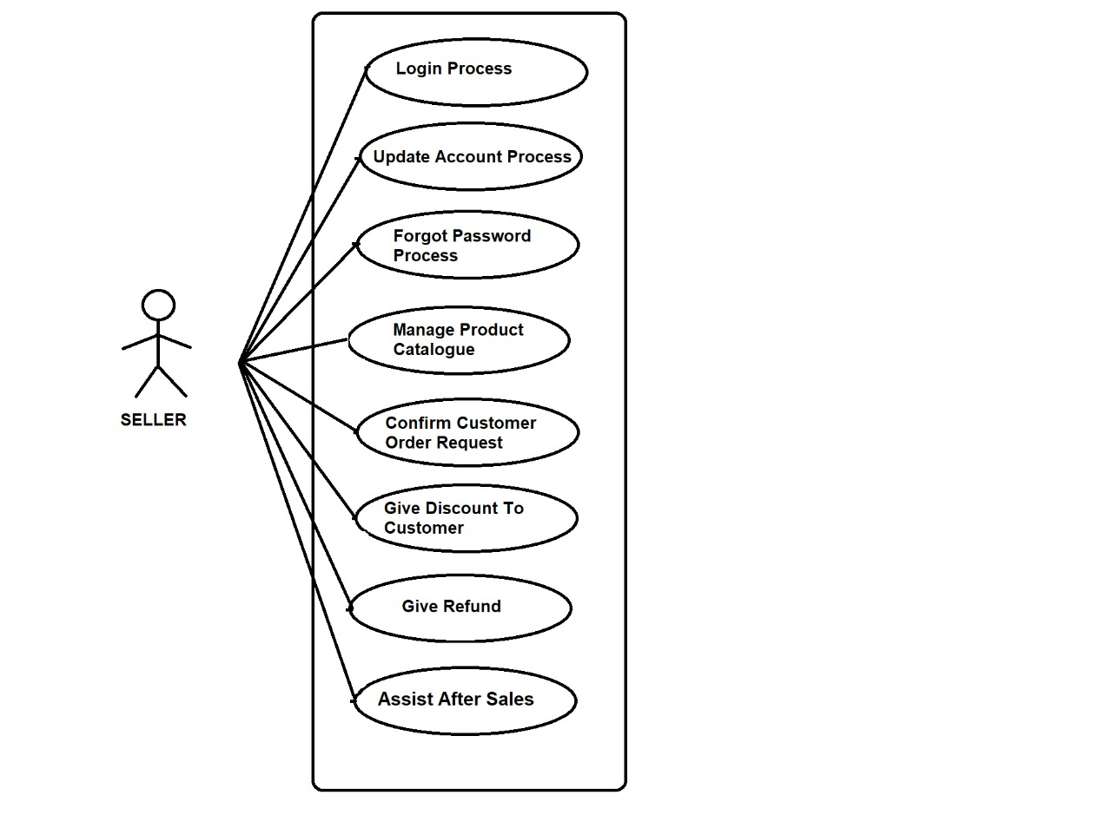

Fig. Seller Module.

### Customer Module.

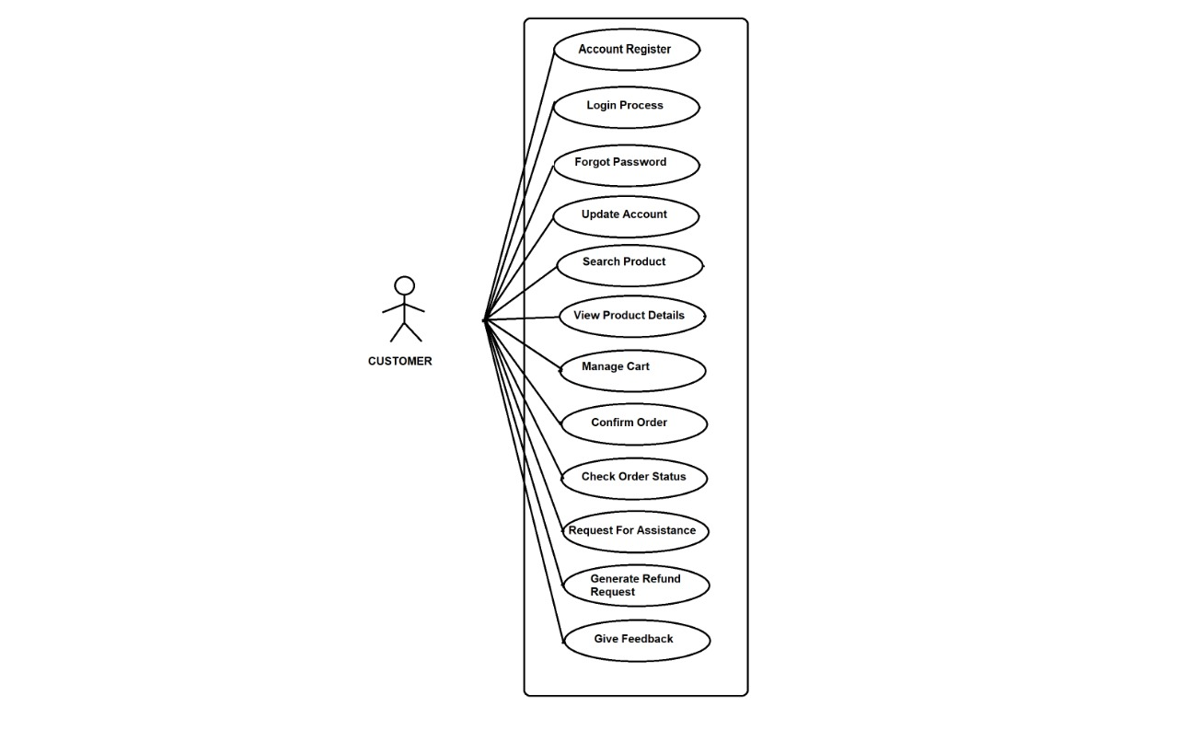

Fig. Customer Module.

### Admin Module.

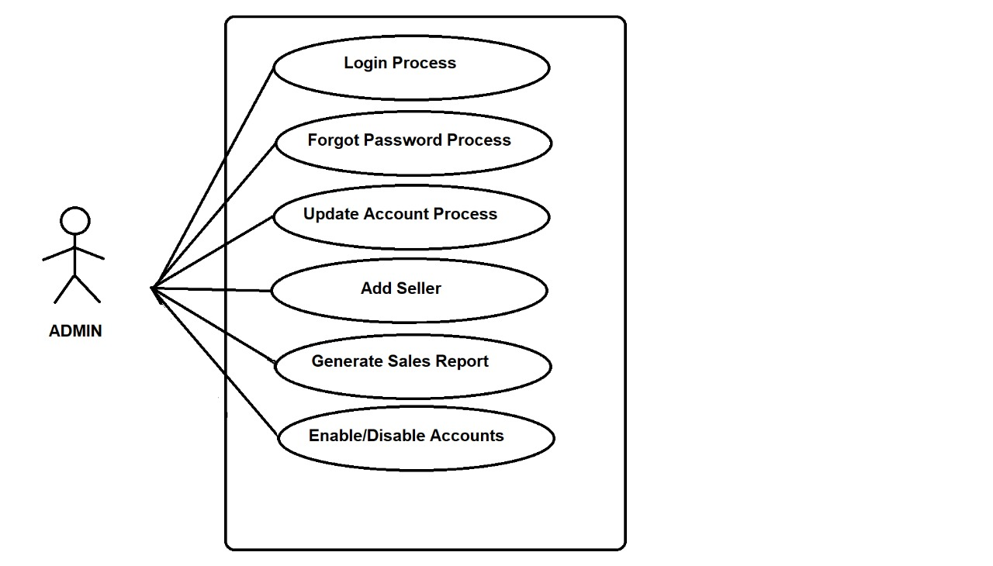

Fig. Admin Module.